**Deploy your Application**

Setting up EKS CTL command line and dependencies

**Please Note:** Amazon EKS clusters require **kubectl**, **kubelet** binaries, and AWS IAM Authenticator for Kubernetes to allow IAM authentication for Kubernetes cluster.

* Download the Amazon EKS-vended kubectl binary from Amazon S3:

Linux: <https://amazon-eks.s3-us-west-2.amazonaws.com/1.10.3/2018-07-26/bin/linux/amd64/kubectl>

* Follow the steps shown below in the screenshot.

**wget https://amazon-eks.s3-us-west-2.amazonaws.com/1.10.3/2018-07-26/bin/linux/amd64/kubectl**

**chmod +x kubectl**

**./kubectl**

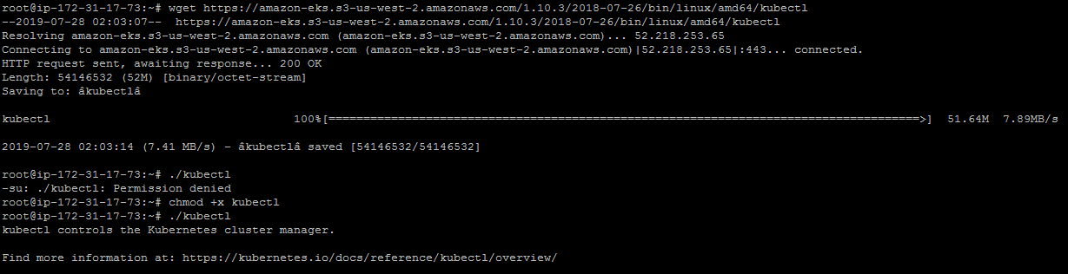

* Configure **kubectl** in PATH variable to call **kubectl** command globally. Follow the set of commands given below to configure PATH variable:

**mkdir bin**

**cp ./kubectl $HOME/bin/kubectl && export PATH=$HOME/bin:$PATH**

**kubectl version**

**kubectl version --short --client**

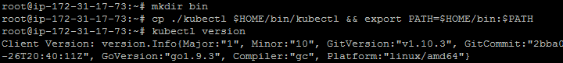

* Configure AWS CLI and aws-iam-authenticator. Follow the set of commands given below to install these command lines. Download the Amazon EKS-vended aws-iam-authenticator binary from Amazon S3:

Linux: <https://amazon-eks.s3-us-west-2.amazonaws.com/1.10.3/2018-07-26/bin/linux/amd64/aws-iam-authenticator>

**wget https://amazon-eks.s3-us-west-2.amazonaws.com/1.10.3/2018-07-26/bin/linux/amd64/aws-iam-authenticator**

**chmod +x ./aws-iam-authenticator**

**cp ./aws-iam-authenticator $HOME/bin/aws-iam-authenticator && export PATH=$HOME/bin:$PATH**

**aws-iam-authenticator help**

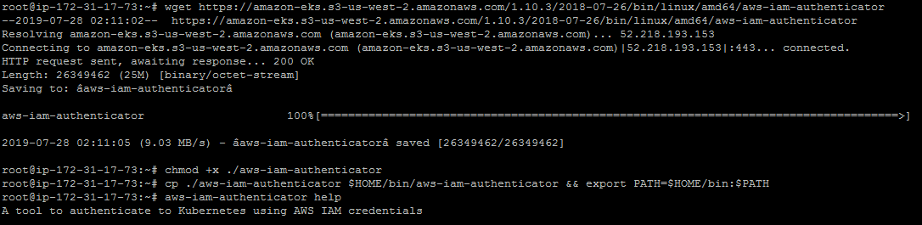

* Install **EKS CTL command line** to create an EKS cluster.

**curl --silent --location "https://github.com/weaveworks/eksctl/releases/download/latest_release/eksctl_$(uname -s)_amd64.tar.gz" | tar xz -C /tmp**

**mv /tmp/eksctl /usr/local/bin**

**eksctl version**

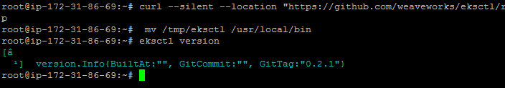

* Install AWS CLI using the sequence of commands given below.

**apt install python-pip**

**pip install awscli**

**aws --version**

* Configure AWS CLI. We need to create **Access Keys** in AWS IAM Console.

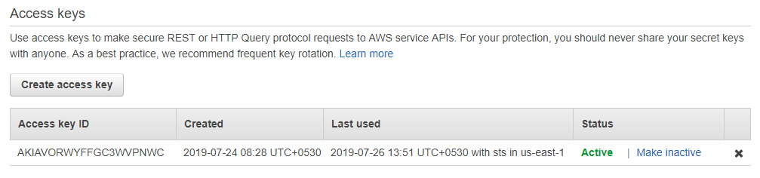

* Click on **Create Access key** and keep the keys safe with you.
* Configure AWS CLI and provide **Access Keys and Secret Access Keys** while configuring AWS CLI.

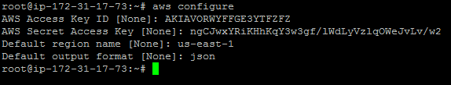

Creating an EKS cluster using eksctl command line

* Create an EKS Cluster using the command below:

**eksctl create cluster --name=EKSCluster --nodes=2 --region=us-west-2**

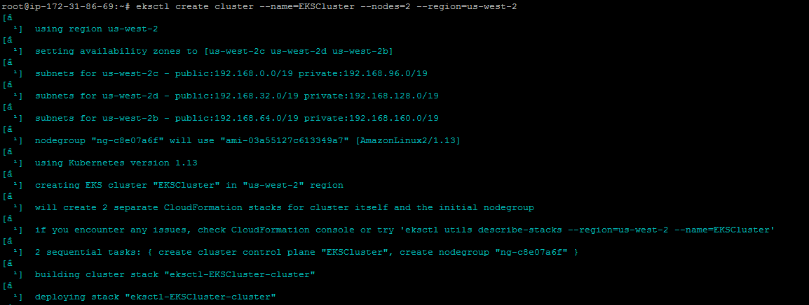

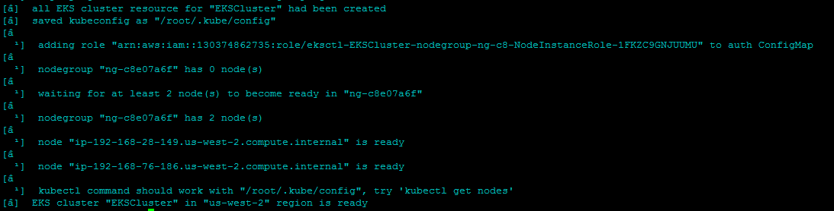

* Validate the cluster using **kubectl get node** command through AWS Console.

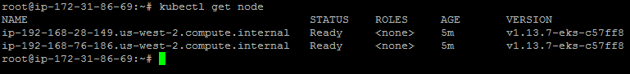

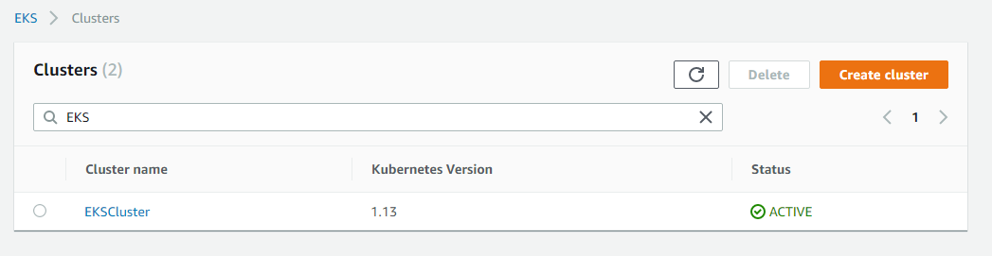

Deploying an application to AWS EKS cluster

* Create Kubernetes deployment and service using the set of commands mentioned below:

**kubectl run kubernetes-bootcamp --image=docker.io/jocatalin/kubernetes-bootcamp:v1 --port=8080**

**kubectl expose deployment/kubernetes-bootcamp --port=8080 --target-port=8080 --type=NodePort**

